Student Suicide Scenario: Higher Education
For guidelines on facilitating a tabletop exercise, including developing goals, objectives, rules, after-action reports, and follow-up actions, please see United Educators’ Crisis Response Planning: A Facilitators Guide for Conducting Tabletop Exercises.
Note: facilitators can either read the scenarios/injects or play the videos for participants.

Scenario
Launch Video (hold the “Control” key down while clicking this link if you’re using Windows)
Albert “AJ” Jones III is a senior at Halliwell College and has been on the varsity football team since his sophomore year. A skilled athlete, AJ has played multiple sports at a competitive level since he was a preteen. He comes from a long line of strong athletes and takes pride in that heritage. Last fall was tough for AJ as he suffered two concussions — one at the beginning of the year and one toward the end of the season. Both concussions required him to miss multiple games and practices; the most recent concussion prevented him from competing in the playoffs.
Due to his injuries and the concerns for his health moving forward, it is uncertain if he will be able to play football again. His family, coaches and teammates have all noticed a change in AJ over the past year and have tried to support and encourage him.
Homecoming Weekend starts tomorrow, and campus is buzzing with preparations. AJ’s Ethics Professor (who happens to be his coach) takes roll and notices AJ isn’t in class. Concerned that AJ will miss an important test, the Professor calls the student health clinic to see if AJ is there and asks that campus safety check his dorm room.
Campus safety arrives at AJ’s dorm room. He isn’t there. They eventually locate him in the bathroom. He’s unresponsive, and one officer calls 911 while the other begins CPR. The college President and Crisis Management Team are notified.
Discussion questions:
- What are your priorities at this point, and how will you proceed?
- Is there a defined protocol for this type of situation?
- How and what do you communicate with faculty, staff, and students on- and off-campus?
Inject 1
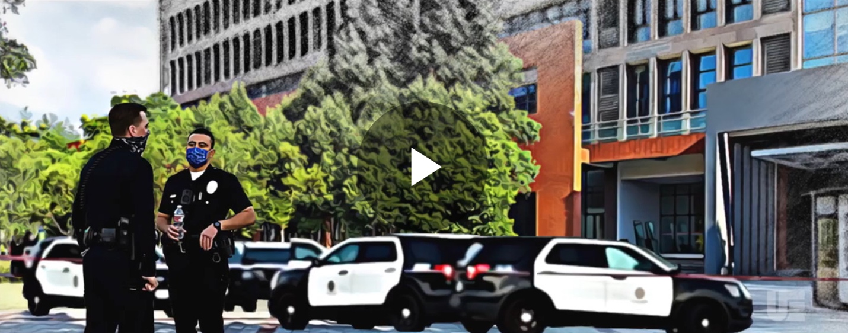
Launch Video (hold the “Control” key down while clicking this link if you’re using Windows)
Police and an ambulance have arrived on campus. AJ hasn’t responded to resuscitation efforts. Word is spreading on campus that emergency vehicles have arrived outside AJ’s dorm building. Police aren’t allowing anyone to enter the building for the next several hours at a minimum. That evening, it’s announced that AJ has died from suicide. This news also quickly spreads throughout the campus community.
Discussion questions:
- Where will those who reside in the dorm building gather? What about their belongings? Where will they be relocated?
- What will be shared with the media? Will they be allowed on campus?
- How do you communicate with your campus community?
- Do you have a timeline for when people will have access to the building again?

Inject 2

Launch Video (hold the “Control” key down while clicking this link if you’re using Windows)
Students are distraught over the news about AJ. It’s been brought to the crisis management team’s attention that two of AJ’s friends created a TikTok video montage about AJ. There are several comments from students and parents, and it is clear that your campus community is grieving.
Discussion questions:
- Does your crisis management plan address responding to a student suicide? If yes, who is involved in decision-making and communication?
- Are there supportive resources available to students and others in the campus community for a death on campus?
- What actions can you take to support grieving students?
- Are there Public Relations concerns with this development? If so, how do you proceed?

